CL Bluehook
CL BLUEHOOK

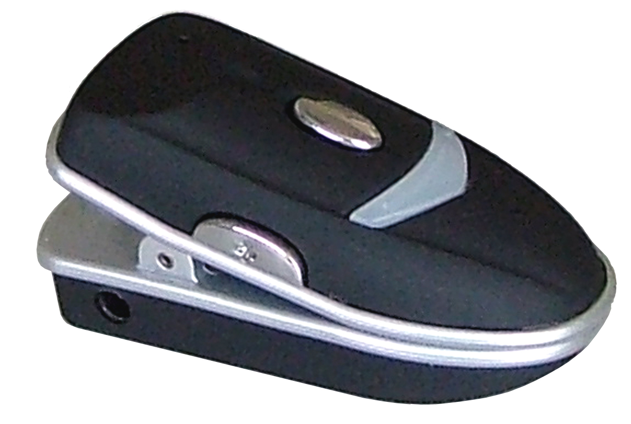

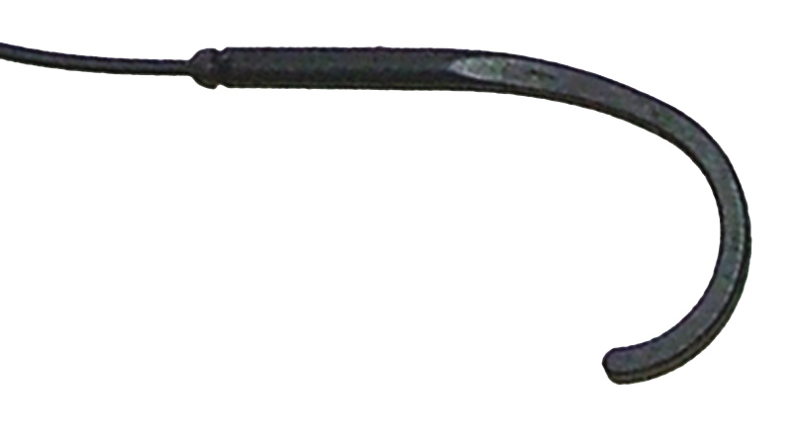

User Guide p.1
Manuel d’utilisation p.25 Benutzerhandbuch S. 43

CONTENTS

CONTENTS 1

INTRODUCTION 3
Unpacking 4

DESCRIPTION 5
General Description 5
LED Description 6

INSTALLATION 7
Setting Up 7

USING THE CL BLUEHOOK 11
Wearing the CL Bluehook 11
Turn the CL Bluehook On 11
Turn the CL Bluehook Off 12
Volume Adjustment 12
Receiving a Call 12
Ending a Call 13
Reject an Incoming Call 13
1

CONTENTS

Making a Call 14
Last Number Redial 14
Voice Transfer 15

SPECIFICATIONS 16

TROUBLESHOUTING 17

SAFETY INFORMATION 19

GUARANTEE 20

RECYCLING DIRECTIVES 23

2

INTRODUCTION

Congratulations on purchasing your Geemarc CL Bluehook. The CL Bluehook uses Bluetooth technology. Bluetooth is an industrial specification for wireless personal area networks (PANs). Bluetooth uses short-range radio links (up to 10 metres) in the 2.4gHz Instrumentation Scientific and Medical (ISM) "free band". Hence, this short-range radio technology allows the wireless networking of devices such as a mobile phone and the CL Bluehook.
1
The CL Bluehook is a standard headset in accordance with Bluetooth 2.0+EDR.
Note: users of digital hearing aids must make sure their aids have been programmed for use with the ‘T’ setting.
This product is ONLY suitable for use when using a hearing aid with a T-coil.

It is important that you read the instructions below in order to use your Geemarc CL BLuehook its full potential. Keep this user guide in a safe place for future reference.

INTRODUCTION

3

Unpacking
When unpacking the CL Bluehook, you should find the following in the box:

- 1 CL Bluehook

- 1 set of Charging Units



For product support and help visit our website at www.geemarc.com
Telephone 01707 384438
Or fax 01707 372529
4

DESCRIPTION

General Description
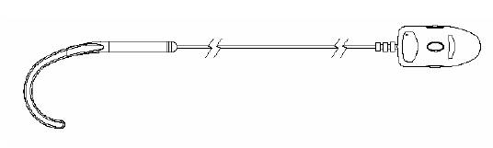

DESCRIPTION

5

LED Description

LED | CL Bluehook Mode
LED flashes blue once every 3 seconds | CL Bluehook is on but ready for use
LED flashes blue and red alternately | CL Bluehook in waiting mode. Ready to be paired with another Bluetooth device (mobile phone)
After LED flashes blue and red alternately, it flashes blue 8 times | Connection between CL Bluehook and mobile phone is being established
LED flashes blue once every 2 seconds | CL Bluehook is paired and ready to be used
LED flashes red | CL Bluehook battery is low

6

INSTALLATION

Setting Up
1
6
3
Before you use the CL Bluehook, please take the following two steps:
1.Charge the battery
2. Pair the CL Bluehook with your mobile phone (Bluetooth connectivity feature turned on)

Battery Charging
Plug the battery charger into the mains supply and switch the supply on. Connect the other end of the battery charger into the charging port on the right hand side of the clip.

During charging a RED LED will be displayed. When charging is complete, the LED will be turned off.

When using the CL Bluehook for the first time, charging could take up to three hours. Please wait until the RED LED is turned off.
7

INSTALLATION

If the RED LED flashes whilst in standby, the CL Bluehook needs recharging.

Note :
Do not overcharge the CL Bluehook. Once the RED LED is no longer displayed, remove the charging unit.
Do not use the CL Bluehook whilst it is being charged.

CL Bluehook Pairing
In order to use the CL Bluehook, it must be paired with a mobile phone.
Pairing is the process of associating Bluetooth devices with each other. When two devices are paired, they establish a permanent, secure link with each other. Paired devices remain paired even when one of the devices is off or the service connection is stopped/interrupted. Therefore, pairing only needs to take place once.

8

INSTALLATION

4  3 | Set the CL Bluehook to power-on mode (press Multifunction Speaking Button for 5 seconds until the BLUE LED flashes every 3 seconds)
 | Ensure there are no other Bluetooth devices in pairing mode within a 10 metre range of the CL Bluehook
 | Press and hold VOL+ and VOL-simultaneously for about 3 seconds until the BLUE and RED LED flash alternately. You are now in waiting mode.
 | Select Bluetooth for the connectivity type on your mobile phone
Set the mobile phone to search and add a new paired device (see mobile phone user guide).
N.B. When the mobile phone finds the CL Bluehook, it may appear as BT019 in the list of paired devices – this is ok.
9

INSTALLATION

 | On finding the the CL Bluehook, the mobile phone will ask for an input ID code. Enter the PIN code of “0000”
 | The BLUE LED should now flash slowly to indicate successful pairing.
 | The CL Bluehook is now in standby and can be used as required.

10

USING THE CL BLUEHOOK

Wearing the CL Bluehook
6
5
You can clip the CL Bluehook onto your clothes and place the hook over your left or right ear.
Note: users of digital hearing aids must make sure their aids have been programmed for use with the ‘T’ setting.

Turn the CL Bluehook On
Press Multifunction Speaking Button for 5 seconds until the BLUE LED flashes. If there is a successful connection, the BLUE LED will start to flash once every 3 seconds.

If you have already paired the CL Bluehook with a mobile phone, the CL Bluehook and the mobile phone will connect automatically when the CL Bluehook is turned on.

11

USING THE CL BLUEHOOK

Turn the CL Bluehook Off
Press Multifunction Speaking Button for 3 seconds until the RED LED flashes. A voice or a beep will be heard from the CL Bluehook. Release the Multifunction Speaking Button and the CL Bluehhok will now turn off.

Volume Adjustment
To increase the volume during a call, press VOL+ gently. To decrease the volume during a call, press VOL- gently.

Receiving a Call
Press Multifunction Speaking Button to receive the call. The microphone on the clip will pick up your voice and you will hear everything via the ear hook.

12

USING THE CL BLUEHOOK

Ending a Call
When your conversation has ended, press Multifunction Speaking Button to end the call.

Reject an Incoming Call
Press VOL-for 3 seconds until you hear a beep, then release the button. This will reject an incoming call.

13

USING THE CL BLUEHOOK

Making a Call
Dial the telephone number on the mobile phone as normal. Once the call is placed, the CL Bluehook will carry the conversation.

You can make a call via voice command if your mobile phone supports this function. The mobile phone must be set to hands free mode. Press and hold VOL+ until you hear a prompt. Say the required name or telephone number loudly and clearly towards the microphone on the CL Bluehook. The required telephone number will be dialed automatically.

Last Number Redial
Press VOL-for 3 seconds until you hear a beep, then release the button to perform last telephone number redial.

Note: This can only take place when in standby mode.
This function only works correctly if the mobile phone has been set to hands free mode.
14

USING THE CL BLUEHOOK

Voice Transfer
If you need to make a call using the mobile phone without the CL Bluehook, press VOL+ for 3 seconds.

15

SPECIFICATION

Working Frequency 2.4-2.4835 gHz ISM Band
Bluetooth Criterion V2.0+EDR
RF Output Power -6 - +4dBm (class2)
RF Sensitivity Superior -75dBm
Effective Distance maximum without obstacle 10m
Working Indication 2 LED (blue and red)
Battery Rechargeable Lithium Polymer Battery
Speaking Time Approx 12 hours
Standby time Approx 250 hours
Charging Time Approx 2-3 hours
Audio Output Power (RL=32ohm) 2.5mw
Working temperature -10C - +45C
Storage Temperature -20C - +65C
Size 54 x 25.5 x 24 mm
Weight 22.5g

16

TROUBLESHOOTING

The RED LED is flashing
- Charge the battery

The CL Bluehook keeps on switching off
- Make sure that the batteries are fully charged
- Make sure you are within a 10 meter range of the mobile phone

Experiencing interference when using the CL Bluehook
- Wireless telephones and wireless networks may cause interference. Keep as far away as possible from these devices whilst using the CL Bluehook.

17

TROUBLESHOOTING

Mobile phone has shown connection with the CL Bluehook, however, the CL Bluehook appears not to work
- Ensure the mobile phone is switched to Bluetooth setting
- Switch the CL Bluehook off and then on again
- Delete the existing Bluetooth connection, then pair the devices together again
- Make sure you are within 10 meter range of the mobile phone
- Make sure that the batteries are fully charged

18

SAFETY INFORMATION

General
10
Do not open the unit. Contact the helpline for all repairs.

Cleaning
Clean the CL Bluehook with a soft cloth. Never use polishes or cleaning agents - they could damage the finish or the electrics inside.

Environmental
Do not expose to direct sunlight.

Always ensure there is a free flow of air over the surfaces of the CL Bluehook.

Do not place any part of your product in water and do not use it in damp or humid conditions e.g. bathrooms.

Do not expose your product to fire or other hazardous conditions.
19

GUARANTEE

From the moment your Geemarc product is purchased, Geemarc guarantee it for the period of one year. During this time, all repairs or replacements (at our discretion) are free of charge. Should you experience a problem then contact our help line or visit our website at www.geemarc.com. The guarantee does not cover accidents, negligence or breakages to any parts. The product must not be tampered with or taken apart by anyone who is not an authorized Geemarc representative. The Geemarc guarantee in no way limits your legal rights.

IMPORTANT: YOUR RECEIPT IS PART OF YOUR GUARANTEE AND MUST BE RETAINED AND PRODUCED IN THE EVENT OF A WARRANTY CLAIM.
Please note: The guarantee applies to
the United Kingdom only

20

GUARANTEE

DECLARATION: Geemarc Telecom SA hereby declares that this product is in compliance with the essential requirements and other relevant provisions of the Radio and Telecommunications Terminal Equipment Directive 1999/5/EEC and in particular article 3 section 1a, 1b and section 3.



21

GUARANTEE

Electrical connection: The apparatus is designed to operate from a 230V 50Hz supply only. (Classified as ‘hazardous voltage’ according to EN60950 standard). The apparatus does not incorporate an integral power on/off switch. To disconnect the power, either switch off supply at the mains power socket or unplug the AC adaptor. When installing the apparatus, ensure that the mains power socket is readily accessible.

Telephone connection: Voltages present on the telecommunication network are classified TNV-3 (Telecommunication Network Voltage) according to the EN60950 standard.

22

RECYCLING DIRECTIVES

The WEEE (Waste Electrical and Electronic Equipment) has been put in place for the products at the end of their useful life are recycled in the best way.
When this product is finished with, please do not put it in your domestic waste bin.
Please use one of the following disposal options:
- Remove the batteries and deposit them in an appropriate WEEE skip. Deposit the product in an appropriate WEEE skip.
- Or, hand the old product to the retailer. If you purchase a new one, they should accept it.
Thus if you respect these instructions you ensure human health and environmental protection.

23

For product support and help visit our website at www.geemarc.com
Telephone 01707 384438
Or fax 01707 372529
13

24
13

